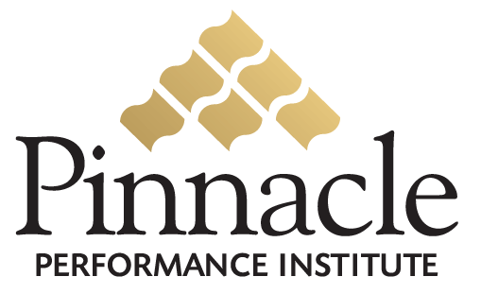

Pinnacle Business Program

Pinnacle is proud to announce the

The New Art and Science of

Referral Marketing

a business program to show companies

how to increase their Customer Referrals

to significantly improve their profits.

This limited-time business program is presented by

Scott Degraffenreid

National renowned Business Consultant,
Behavioral Statistician, Social Network Analyst,
and author of “Referral Marketing”

Access to the Pinnacle Business Program
Is available on the Internet
By your local Pinnacle Account Executive

